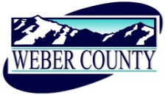

NOTICE OF CANCELLATION REGULAR COMMISSION MEETINGS OF THE
BOARD OF COMMISSIONERS OF WEBER COUNTY, UTAH

PUBLIC NOTICE is hereby given that Commission Meetings scheduled for December 24 and 31, 2019 have been canceled. The next Regular Meeting of the Board of Commissioners of Weber County will be held on January 7, 2020 @ 10:00 a.m.

CERTIFICATE OF POSTING

The undersigned, duly appointed Administrative Coordinator in the County Commission Office, does hereby certify that the above Notice and Agenda were posted as required by law this 17th day of December 2019.

_________________________________
Shelly Halacy

